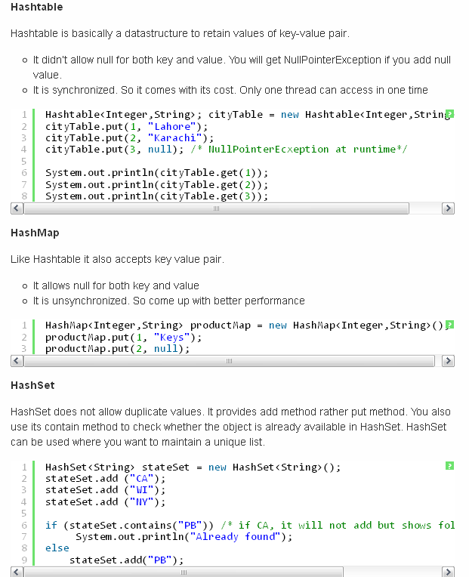

Difference between TreeMap, TreeSet, ArrayList, HashMap, HashSet and TreeSet

HashSet:
- Class offers constant time performance for the basic operations (adds, remove, contains and size).
- it does not guarantee that the order of elements will remain constant over time
- Iteration performance depends on the 'initial capacity' and the 'load factor' of the HashSet.
  - It's quite safe to accept default load factor but you may want to specify an initial capacity that's about twice the size to which you expect the set to grow.
- HashSet is much faster than TreeSet (constant-time versus log-time for most operations like add, remove and contains) but offers no ordering guarantees like TreeSet.

TreeSet:
- guarantees log(n) time cost for the basic operations (add, remove and contains)
- guarantees that elements of set will be sorted [ascending, natural, or the one specified by you via it's constructor]
- doesn't offer any tuning parameters for iteration performance
- offers few handy methods to deal with the ordered set like first(), last(), headSet(), and tailSet() etc

Important points:
- Both guarantee duplicate-free collection of elements
- It is generally faster to add elements to the HasSet and then convert the collection to a TreeeSet for a duplicate-free sorted traversal.
- None of these implementation are synchronized. That is if multiple threads access a set concurrently, and at least one of the threads modifies the set, it must be synchronized externally.
- LinkedHashSet is in some sense intermediate between HashSet and TreeSet. Implemented as a hash table with a linked list running through it, however it provides insertion-ordered iteration which is not same as sorted traversal guaranteed by TreeSet
So choice of usage depends entirely on your needs but I feel that even if you need a ordered collection then you should still prefer HashSet to create the Set and then convert it into TreeSet.
- e.g. Set s = new TreeSet(hashSet);

NOTE:
- TreeMap lets you access the elements in your collection by key, or sequentially by key. It has considerably more overhead than ArrayList or HashMap.
- Use HashMap when you don’t need sequential access, just lookup by key.
- Use an ArrayList and use Arrays. Sort if you just want the elements in order.
- TreeMap keeps the elements in order at all times. With ArrayList you just sort when you need to.

